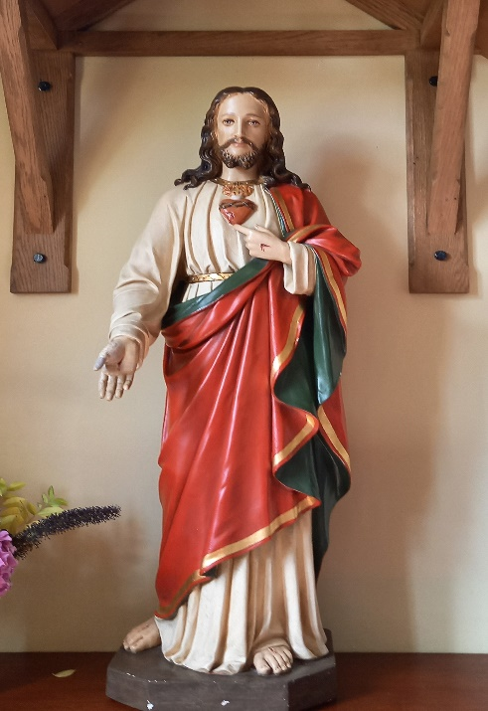
St Theresa’s and Sacred Heart
53 Front Street
Birstall, Leicestershire
LE4 4DQ
Tel: 0116 2929939
E-mail: theresa.sacredheart@gmail.com
www:theresa.sacredheart.co.uk

Application for the Sacrament of Baptism
Dear Parents,
G
OD has blessed you in your desire to have your child baptised in the Catholic Church. Through baptism your child will receive God’s blessing and become a member of Christ’s Body, the Church. At baptism, you make promises and a commitment to bring up your child in the love and knowledge of God. You undertake to educate your child in the Catholic faith and to bring him or her with you to Church in the formative years.
To help you prepare for your child’s baptism we provide a baptism preparation meeting with a priest or deacon or catechists of the parish and you can pick up information about this from the parish office. Please indicate on this form if you have already attended such a course in this parish. The course leaders go through the baptismal celebration with you to help you understand its meaning and implications.
When you have completed and signed the form overleaf and the declaration below, please return it to the parish office. It is customary to make a discretionary contribution for the Baptism to the priest.
I look forward to your child’s baptism, to welcoming him/her to the family of the Church and I pray that God will bless you and your family.

Fr. Tom Thomas ic

Parental Declaration
I wish to have our child baptised and therefore I promise to bring up him/her in the faith and practice of the Catholic Church. I will try to do my best to fulfil this promise by living out my own Catholic faith and giving good example to our child by prayer and receiving the Sacraments and especially by attendance at Mass. The information I have given on this form is correct.

Signatures of parents:
Mother: _______________________________ Father: _________________________________
The above declaration and promise is required of Catholic parents. If one of the parents is not Catholic, he/she is invited to sign below to indicate his/her consent to the baptism.

Signature of non-Catholic parent: _________________________________________
Priest: | Date & time of Baptism:
Date of Presentation:

Full name of person to be baptised: | Date of birth:
Father’s full name: | Religion:
Mother’s full name: | Religion:
Mother’s maiden name:
Place and date of marriage:
Home address and postcode:
Contact telephone number/s: | Email address:
GODPARENTS: According to Canon Law (cc.872-4) there may be two godparents or sponsors, although one is sufficient. They should be practising Catholics who have been confirmed and received the Eucharist. Normally it is expected that godparents/sponsors should be at least sixteen years of age. A non-Catholic may be admitted only in company with a Catholic sponsor, and then simply as witness to the Baptism. Please ask the God parents to bring letters from their respective parish priests.
Godparents’ names: | Religion:
Parents should attend a preparation session before the Baptism. Please indicate dates attended below:
1st session:
FAMILIES RESIDING OUTSIDE THE PARISH OF ST. THERESA AND SACRED HEART: If you are resident in a different parish, it is customary to obtain the permission of your parish priest for the Baptism to take place at St. Theresa and Sacred Heart. Please ask him to indicate his consent by signing this form below:

Signature of Parish Priest: ___________________________ Date: _________________

