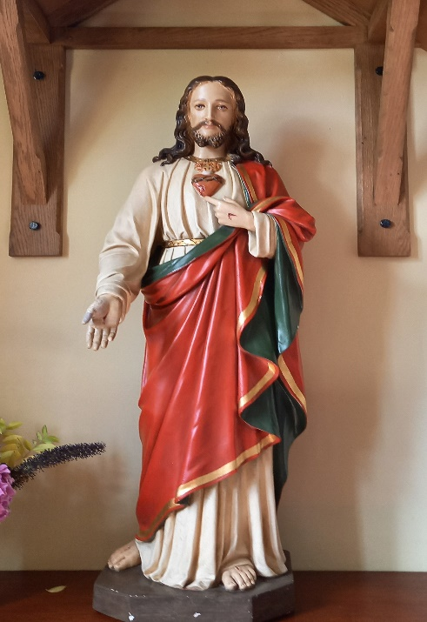
St Theresa’s and Sacred Heart
53 Front Street
Birstall, Leicestershire
LE4 4DQ
Tel: 0116 2929939
E-mail: theresa.sacredheart@gmail.com
www.theresa.sacredheart.co.uk

APPLICATION FORM
For the
SACRAMENT OF CONFIRMATION

Candidate’s SURNAME …………………………………………..……………..…………...............
Candidate’s CHRISTIAN NAME(S) ………….…………………………………..….……..............
Candidate's Date & Place of Birth …………………………………………………………...............
Candidate’s Date and Place of Baptism (full name and address please) ……………………............
…………………………………………..………………………………………………………............
(You will need to supply a copy of your Baptismal Certificate in the next few weeks)
Candidate’s e-mail address ……………..…………………………………………………….............
Candidate’s Parents:
Father’s name …………………………………………………………………….…..….....................
Father’s Religion …………………………………………………………………….………............
Mother’s name ………………………………………………………………………….......................
Mother’s Religion …………………………………………………………….……………….............
Parental Home Address ……………..…….……………………………………….…………........... ………………………………………………..……………………………………….………………...…………………………………………………..…….................... Post Code ………..……………
Parental Home Telephone Number or e-mail address.......................................................................
...............................................................................................................................................................

